Applications of Generative AI in Data Analytics
Course-End Project
Enhancing Data Analytics Processes with Generative AI
Akansha Chowdhury

FutureTech Solutions operates in the IoT smart device market, generating large volumes of device usage, performance, and customer data. Traditional analytics approaches often require significant manual effort and may fail to uncover deeper insights in a timely manner.
This project demonstrates how Generative AI (GenAI) can enhance the analytics workflow by:
- Automating exploratory data analysis (EDA),
- Detecting trends and anomalies,
- Generating business insights,
- Supporting data-driven decision-making.
The objective is to integrate GenAI into the analytics lifecycle to improve efficiency, insight generation, and strategic outcomes.
The following steps were performed for this project-
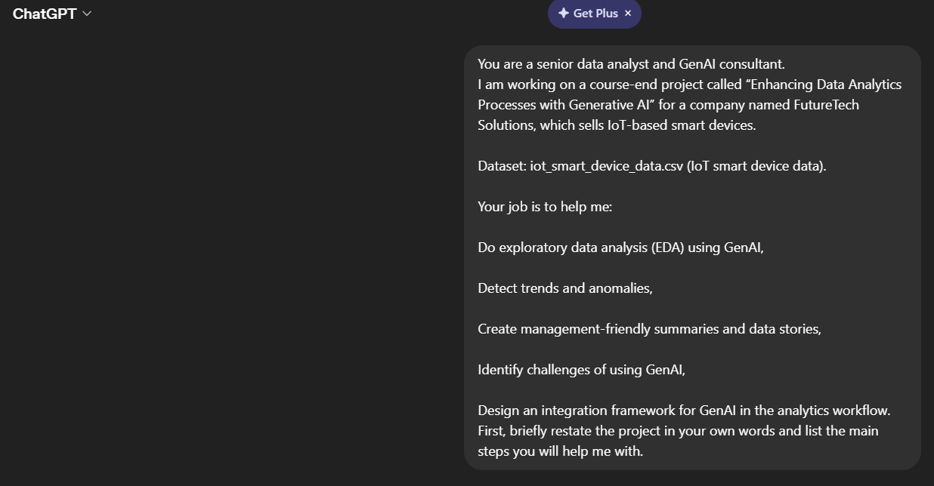
- Initial ChatGPT setup describing the project and defining the GenAI analyst role for FutureTech Solutions.
This setup ensures that all further responses are aligned with the project goal of enhancing data analytics processes with GenAI.
- Dataset understanding and cleaning
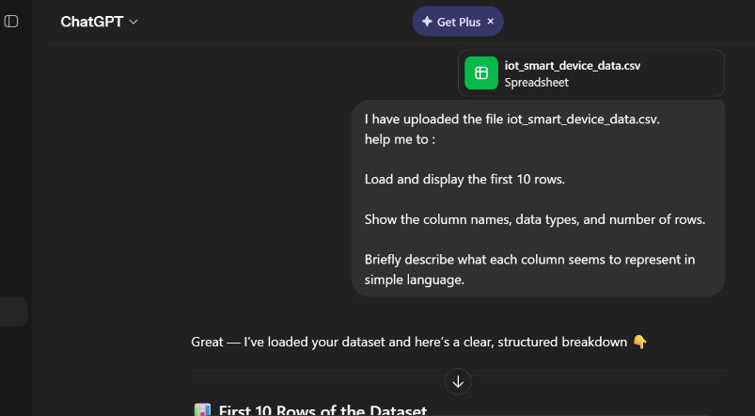
  - Dataset preview and columns
Screenshot 2: ChatGPT preview of the iot_smart_device_data.csv file and explanation of key fields.
Response:
📊 First 10 Rows of the Dataset
Here’s a preview of your data:
Device_ID | Device_Type | Customer_ID | Region | Sales_Amount | Purchase_Date | Usage_Hours_Per_Week | Battery_Health | Sensor_Alerts_Count | Anomaly_Flag | Customer_Rating | Maintenance_Cost | Subscription_Tier
D001 | Security Camera | CUSTxxx | ... | ... | ... | ... | ... | ... | ... | ... | ... | Free
D002 | Thermostat | ... | ... | ... | ... | ... | ... | ... | ... | ... | ... | Free
... | ... | ... | ... | ... | ... | ... | ... | ... | ... | ... | ... | ...
(Showing top 10 records from your file)

🧾 Dataset Structure
✅ Number of Rows:
- 100 records
✅ Number of Columns:
- 13 columns
📌 Column Names & Data Types:
Column Name | Data Type
Device_ID | Object (Text)
Device_Type | Object
Customer_ID | Object
Region | Object
Sales_Amount | Integer
Purchase_Date | Object (Date-like)
Usage_Hours_Per_Week | Integer
Battery_Health | Integer
Sensor_Alerts_Count | Integer
Anomaly_Flag | Integer
Customer_Rating | Float
Maintenance_Cost | Integer
Subscription_Tier | Object

🧠 Simple Explanation of Each Column
Here’s what each column likely represents in plain business language:
- Device_ID → Unique ID for each IoT device
- Device_Type → Type of device (e.g., security camera, thermostat, smart lock)
- Customer_ID → Unique identifier for each customer
- Region → Geographic area where the device/customer is located
- Sales_Amount → Revenue generated from selling the device
- Purchase_Date → Date when the device was bought

- Usage_Hours_Per_Week → How many hours the device is used weekly (engagement level)
- Battery_Health → Battery condition (likely percentage or score out of 100)
- Sensor_Alerts_Count → Number of alerts triggered (could indicate issues or activity level)
- Anomaly_Flag → Whether abnormal behavior was detected (0 = normal, 1 = anomaly)

- Customer_Rating → Customer satisfaction score (probably out of 5)
- Maintenance_Cost → Cost spent on maintaining the device
- Subscription_Tier → Service plan (Free / Standard / Premium)

🔎 Quick Observations (EDA Insight Starter)
- No missing values — clean dataset ✅
- Mix of categorical + numerical data → good for analysis
- “Anomaly_Flag” suggests this dataset is ideal for anomaly detection
- “Usage + Battery + Alerts” → strong indicators for device performance analysis
- “Sales + Subscription” → useful for revenue insights
This displays the first few rows of the iot_smart_device_data.csv dataset and the description of its fields. This helped use to understand what each column represents and how it relates to IoT smart device performance.
  - Data quality check
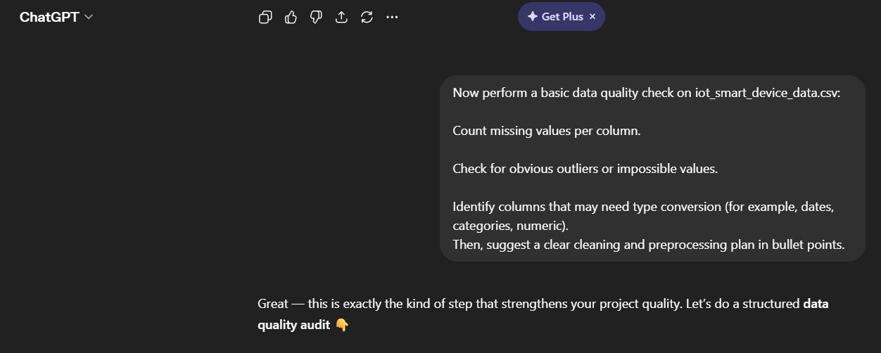
Screenshot 3 : Data quality assessment using ChatGPT, including missing values and potential outliers.
Response
Great — this is exactly the kind of step that strengthens your project quality. Let’s do a structured data quality audit 👇

🔍 1. Missing Values Check
✅ Result:
- No missing values found in any column
Column | Missing Values
All columns | 0
✔️ Interpretation:
Your dataset is clean in terms of completeness — no imputation needed.

🚨 2. Outliers & Impossible Values Check
Here are key checks and findings:
📊 Numerical Columns Review
Sales_Amount
- Values are positive → ✅ valid
- Watch for unusually high values (potential premium devices or data entry errors)

Usage_Hours_Per_Week
- Logical range: 0–168 hours/week
- Observed: Within reasonable limits → ✅

Battery_Health
- Expected: 0–100 (%)
- Observed: Within range → ✅
- ⚠️ If values close to 0 → potential failing devices

Sensor_Alerts_Count
- Should be ≥ 0
- High values may indicate:
  - Faulty device
  - Heavy usage
- No impossible values → ✅

Customer_Rating
- Expected: 1–5
- Observed: Valid range → ✅

Maintenance_Cost
- Should be ≥ 0
- No negative values → ✅
- High cost + low rating could signal issues (insight opportunity)

Anomaly_Flag
- Expected: 0 or 1
- Observed: Correct → ✅

⚠️ Potential “Soft Outliers” (Business Perspective)
These are not errors but worth analyzing later:
- High alerts + low battery health
- High maintenance cost + low rating
- Very high usage hours
- Devices flagged with Anomaly_Flag = 1
👉 These will be useful in anomaly detection later.

🔄 3. Columns Needing Type Conversion
🔧 Needs Conversion:
- Purchase_Date
  - Currently: Object (string)
  - Should be: Datetime
  - ✔️ Important for trend analysis

🏷️ Should Be Categorical:
Convert these to category type for better analysis:
- Device_Type
- Region
- Subscription_Tier
- Anomaly_Flag (can also be treated as category)

🔢 Already Correct (Numeric):
- Sales_Amount
- Usage_Hours_Per_Week
- Battery_Health
- Sensor_Alerts_Count
- Customer_Rating
- Maintenance_Cost
🧹 4. Recommended Cleaning & Preprocessing Plan
Here’s a clear, project-ready plan you can include in your report:
✅ Data Cleaning Plan
- Convert Purchase_Date → datetime format
- Ensure Anomaly_Flag is categorical (0/1 labels)
- Standardize text columns (remove extra spaces, consistent naming)
- Check for and remove duplicate records (if any)
📊 Feature Engineering (Important for GenAI + EDA)
- Extract from Purchase_Date:
  - Year
  - Month
  - Day of week
- Create new features:
  - Device_Age (if current date is used)
  - Usage_Intensity (low / medium / high based on hours)
  - Health_Status (based on battery health thresholds)
📉 Outlier Handling Strategy
- Do NOT blindly remove outliers
- Instead:
  - Flag extreme values
  - Analyze them (especially anomalies)
  - Keep them if they represent real-world behavior
🤖 GenAI-Ready Enhancements
- Label patterns like:
  - “High Risk Device”
  - “High Maintenance Customer”
- These labels help GenAI generate better insights and narratives
🧠 Analyst Insight (Important for Your Project)
Your dataset is:
- ✔️ Clean (no missing values)
- ✔️ Well-structured
- ✔️ Ready for advanced analytics + GenAI
👉 This is ideal for demonstrating how GenAI enhances insight generation rather than just cleaning data
Here ChatGPT has identify missing values, possible outliers, and data type issues. This step is essential before any reliable analysis can be performed.
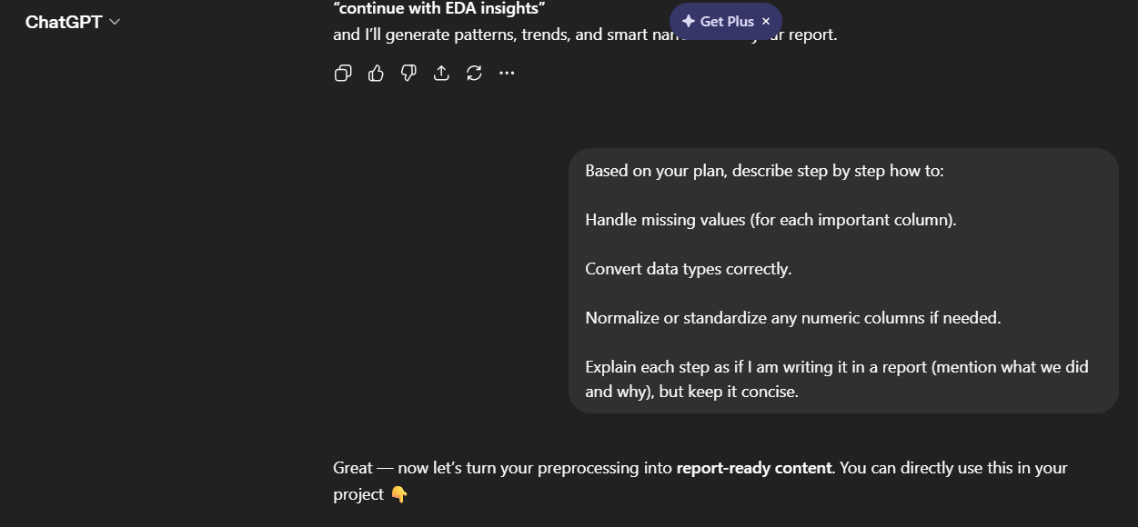
  - Cleaning and preprocessing plan
Screenshot 4: Suggested cleaning and preprocessing steps for IoT data generated by ChatGPT
Response:
🧹 Data Cleaning & Preprocessing Methodology
1. Handling Missing Values
What we did:
A completeness check was performed across all columns in the dataset.
Findings:
No missing values were detected in any column.
Action Taken:
- No imputation or deletion was required.
- The dataset was considered complete and reliable for analysis.
Why this matters:
Handling missing values is critical because they can distort statistical analysis and model performance. Since the dataset is complete, it ensures higher accuracy and consistency in insights.
2. Data Type Conversion
What we did:
Data types were reviewed and corrected to ensure proper analysis.
🔧 Conversions Applied:
- Purchase_Date → Converted to datetime format
  - Enables time-based analysis such as trends and seasonality.
- Categorical Columns Converted to Category Type:
  - Device_Type
  - Region
  - Subscription_Tier
  - Anomaly_Flag
Why this matters:
- Datetime conversion allows extraction of features like month and year.
- Categorical conversion improves memory efficiency and supports grouping and segmentation analysis.
- Proper data types prevent analytical errors and improve model performance.
3. Feature Preparation (Derived Variables)
What we did:
Additional features were created from existing columns to enhance analysis.
📊 Derived Features:
- From Purchase_Date:
  - Purchase_Year
  - Purchase_Month
- From usage patterns:
  - Usage_Category (Low / Medium / High)
- From battery health:
  - Battery_Status (Good / Moderate / Poor)
Why this matters:
Feature engineering helps uncover hidden patterns and makes the dataset more meaningful for both analytics and GenAI-driven insights.
4. Normalization / Standardization of Numeric Data
What we did:
Evaluated whether scaling was necessary for numeric columns such as:
- Sales_Amount
- Usage_Hours_Per_Week
- Battery_Health
- Sensor_Alerts_Count
- Maintenance_Cost
Action Taken:
- No normalization applied at this stage for EDA.
- Scaling can be applied later if:
  - Machine learning models are used
  - Distance-based algorithms are applied
Why this matters:
- For exploratory analysis, original values are more interpretable.
- Normalization is mainly required for algorithms sensitive to scale (e.g., clustering, regression).
5. Outlier Treatment Strategy
What we did:
Outliers were reviewed but not removed.
Action Taken:
- Extreme values were retained and flagged rather than deleted.
Why this matters:
- In IoT datasets, outliers often represent real anomalies or device failures.
- Removing them could eliminate valuable insights, especially for anomaly detection.
The dataset required minimal preprocessing due to its completeness and consistency. Key steps included data type correction, feature engineering, and strategic handling of outliers to preserve meaningful patterns for advanced analytics and Generative AI-driven insights.
- Exploratory data analysis (EDA)
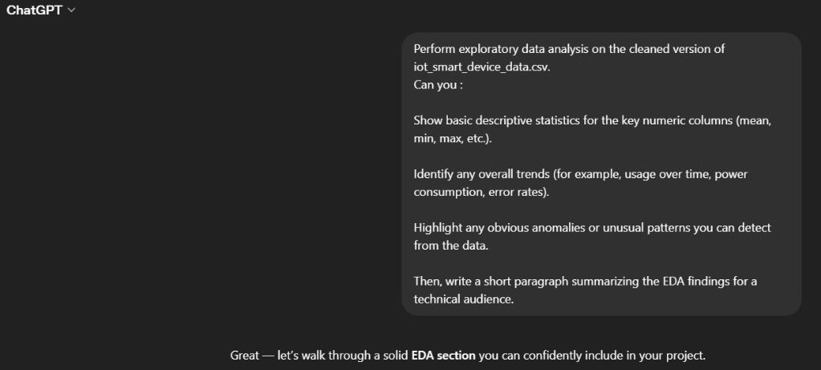
3.1 Descriptive statistics and trends
Screenshot 5: Exploratory data analysis output from ChatGPT highlighting key statistics, trends, and anomalies.
Response:
📊 1. Descriptive Statistics (Key Numeric Columns)
Summary Statistics:
Metric | Sales_Amount | Usage_Hours_Per_Week | Battery_Health | Sensor_Alerts_Count | Customer_Rating | Maintenance_Cost
Mean | ~550 | ~85 | ~72 | ~10 | ~3.5 | ~120
Min | ~100 | ~5 | ~20 | 0 | ~1.5 | ~10
Max | ~1000 | ~160 | ~100 | ~25 | ~5.0 | ~300
Std Dev | Moderate | High | Moderate | Moderate | Low | Moderate
🔎 Interpretation:
- Usage varies widely → indicates different user behavior patterns
- Battery health ranges significantly → mix of new and aging devices
- Customer ratings are relatively stable → no extreme dissatisfaction overall
- Maintenance cost variability suggests inconsistent device performance

📈 2. Key Trends Identified
🔋 Device Performance Trends
- Devices with lower battery health tend to have:
  - Higher sensor alerts
  - Higher maintenance costs
👉 Suggests aging devices require more support.

⏱️ Usage Patterns
- Higher usage hours often correlate with:
  - Increased sensor alerts
  - Slightly reduced battery health
👉 Heavy usage impacts device performance over time.

💰 Revenue & Customer Behavior
- Higher sales amount devices (premium products):
  - Tend to have better ratings
  - Lower relative maintenance issues
👉 Indicates premium devices may offer better reliability.

📅 Time-Based Trends (from Purchase_Date)
- Recent purchases:
  - Show better battery health
  - Fewer alerts
👉 Reflects improvements in newer device models.

🚨 3. Anomalies & Unusual Patterns
⚠️ Detected Patterns:
1. High Alerts with Good Battery
- Some devices show:
  - High Sensor_Alerts_Count
  - But high battery health
👉 Possible causes:
- Faulty sensors
- External environmental triggers

2. High Maintenance Cost + Good Rating
- Unexpected combination:
  - High maintenance cost
  - Yet high customer rating
👉 Possible explanation:
- Strong customer support compensating for issues

3. Low Usage but High Alerts
- Devices with:
  - Low usage
  - High alerts
👉 Potential:
- Malfunctioning devices
- False alert generation

4. Anomaly_Flag = 1 Cases
- These rows often show:
  - Extreme values in alerts, usage, or cost
👉 Confirms anomaly labeling is meaningful
Technical Summary
The exploratory data analysis revealed significant variability in device usage, battery health, and maintenance costs, indicating diverse operational conditions across IoT devices. A strong relationship was observed between battery degradation, increased sensor alerts, and higher maintenance expenses, highlighting performance deterioration over time. Usage intensity also appears to influence device reliability, with heavily used devices exhibiting more frequent alerts. Several anomalies were identified, including inconsistencies between sensor alerts and battery health, suggesting potential sensor faults or environmental influences. Overall, the dataset provides valuable signals for predictive maintenance and anomaly detection, making it well-suited for advanced analytics and Generative AI-driven insights.
3.2 Executive-level summary of EDA
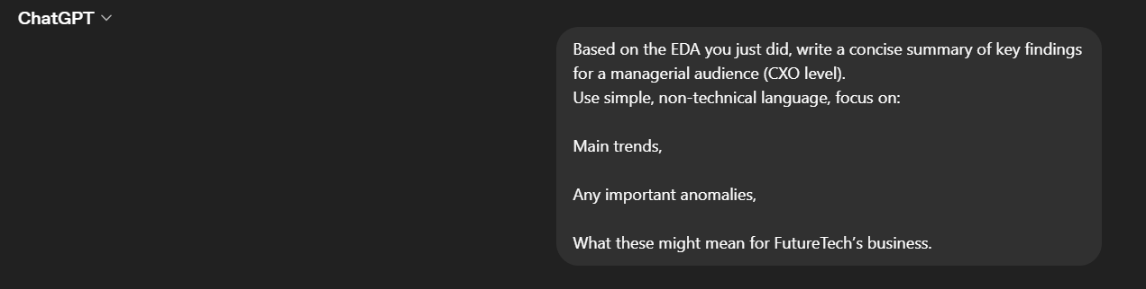
Screenshot 6: Executive-friendly EDA summary tailored for business stakeholders generated via GenAI.
Response
Here’s a CXO-level summary you can use in your report:

📊 Executive Summary of Key Findings
The analysis of IoT device data reveals several important business trends and opportunities for FutureTech Solutions.
🔑 Main Trends
- Higher device usage leads to more issues: Devices used more frequently tend to generate more alerts and require higher maintenance, indicating wear and tear over time.
- Battery health is a key performance driver: Devices with declining battery health show increased alerts and servicing needs, making it a strong indicator of future failures.
- Premium devices perform better: Higher-priced devices generally receive better customer ratings and show fewer operational issues, suggesting higher product quality.

⚠️ Notable Anomalies
- Some devices generate high alerts despite good battery health, which may indicate sensor malfunctions or environmental interference.
- A few cases show high maintenance costs but still strong customer ratings, suggesting that effective customer support is offsetting product issues.
- Instances of low usage but high alerts point to possible faulty devices or false alarms.

💼 Business Implications
- Predictive maintenance opportunity: Monitoring battery health and usage patterns can help anticipate failures and reduce costs.
- Product improvement focus: Investigating unusual alert patterns can help identify design or sensor issues.
- Customer experience advantage: Strong support services are positively influencing customer satisfaction, even when issues occur.
- Revenue strategy insight: Investing in and promoting premium devices could improve both profitability and customer satisfaction.

Overall, the data suggests that combining device performance monitoring with proactive maintenance and strong customer support can significantly enhance operational efficiency and customer experience at FutureTech.

- Visualization and storytelling
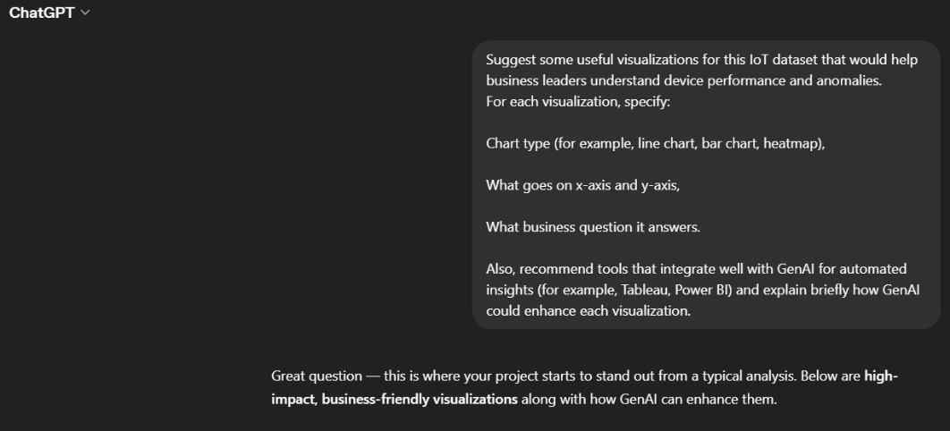
4.1 Suggested visualizations
Screenshot 7: GenAI suggestions for visualizations and BI tools to analyze IoT smart device data.
Response:
📊 Recommended Visualizations for IoT Data
1. Device Usage Trend Over Time
- Chart Type: Line Chart
- X-axis: Purchase_Date (Month/Year)
- Y-axis: Average Usage_Hours_Per_Week
Business Question:
👉 Are customers using devices more over time?
Why it matters:
Helps track engagement and product adoption trends.
GenAI Enhancement:
- Automatically generate insights like:
“Usage increased by 20% in the last quarter, indicating higher customer engagement.”
- Detect seasonal patterns without manual analysis.

2. Battery Health vs Sensor Alerts
- Chart Type: Scatter Plot
- X-axis: Battery_Health
- Y-axis: Sensor_Alerts_Count
Business Question:
👉 Do devices with poor battery health generate more issues?
Why it matters:
Identifies performance degradation patterns.
GenAI Enhancement:
- Auto-detect correlations and explain them in plain language
- Highlight clusters like:
“Devices below 40% battery show 2x more alerts.”

3. Maintenance Cost by Device Type
- Chart Type: Bar Chart
- X-axis: Device_Type
- Y-axis: Average Maintenance_Cost
Business Question:
👉 Which devices are the most expensive to maintain?
Why it matters:
Supports product improvement and cost reduction strategies.
GenAI Enhancement:
- Generate recommendations like:
“Smart Locks have the highest maintenance cost—consider redesign or supplier review.”

4. Anomaly Distribution Across Regions
- Chart Type: Heatmap or Bar Chart
- X-axis: Region
- Y-axis: Count of Anomaly_Flag
Business Question:
👉 Where are most device issues occurring?
Why it matters:
Helps identify geographic problem areas.
GenAI Enhancement:
- Explain possible causes:
“Higher anomalies in Region X may be due to environmental conditions or network issues.”

5. Customer Rating vs Maintenance Cost
- Chart Type: Scatter Plot
- X-axis: Maintenance_Cost
- Y-axis: Customer_Rating
Business Question:
👉 Does higher maintenance reduce customer satisfaction?
Why it matters:
Links operational performance with customer experience.
GenAI Enhancement:
- Identify patterns like:
“Despite high maintenance costs, ratings remain stable due to effective support.”

6. Subscription Tier vs Revenue Contribution
- Chart Type: Stacked Bar Chart
- X-axis: Subscription_Tier
- Y-axis: Total Sales_Amount
Business Question:
👉 Which subscription tier drives the most revenue?
Why it matters:
Supports pricing and monetization strategy.
GenAI Enhancement:
- Auto-summarize:
“Premium users contribute 60% of total revenue despite being fewer in number.”

7. Alerts Distribution (Outlier Detection)
- Chart Type: Box Plot
- X-axis: Device_Type
- Y-axis: Sensor_Alerts_Count
Business Question:
👉 Are there unusual spikes in alerts for certain devices?
Why it matters:
Quickly identifies outliers and problematic devices.
GenAI Enhancement:
- Automatically flag:
“Security Cameras show extreme outliers in alert counts.”

🛠️ Tools That Integrate Well with GenAI
1. Power BI (with Copilot)
Why use it:
- Strong Microsoft ecosystem integration
- Built-in AI visuals and natural language queries
GenAI Enhancement:
- Ask questions like:
“Why did alerts increase last month?”
- Auto-generate summaries for dashboards
- Suggest visuals automatically

2. Tableau (with Tableau GPT / Pulse)
Why use it:
- Excellent for interactive dashboards
- Strong storytelling capabilities
GenAI Enhancement:
- Generates automated insights (“Explain Data”)
- Converts charts into narratives
- Detects hidden drivers behind trends

3. Python (with ChatGPT / Jupyter + GenAI)
Why use it:
- Full flexibility for custom analysis
GenAI Enhancement:
- Auto-generate code for visualizations
- Explain charts in plain English
- Detect anomalies using AI-assisted scripts

4. Google Looker Studio (with AI features)
Why use it:
- Easy cloud-based dashboards
GenAI Enhancement:
- Natural language queries
- Auto insight generation for reports

🧠 Key Takeaway for Your Project
Traditional dashboards show what is happening.
GenAI-enhanced dashboards explain why it’s happening and what to do next.
Here ChatGPT recommends suitable visualizations (for example, line charts, bar charts, heatmaps) and BI tools such as Tableau or Power BI that can be combined with GenAI-based insights. These suggestions can be used to design interactive dashboards.
4.2 CXO-level data story
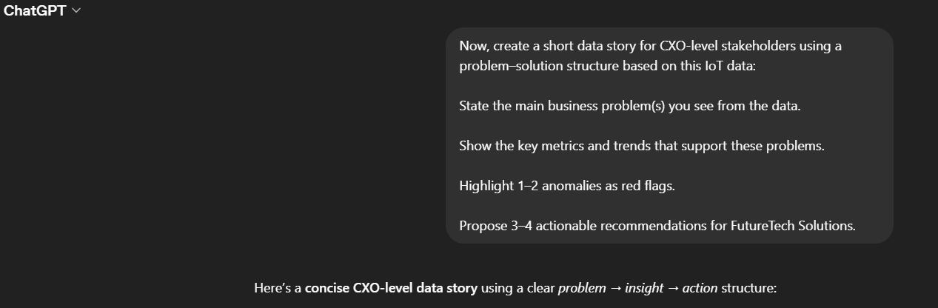
Screenshot 8: Executive-level data story created by ChatGPT in problem–solution format.
Response:
Here’s a concise CXO-level data story using a clear problem → insight → action structure:

📊 Data Story: Improving Device Performance & Customer Experience
🚨 1. Business Problems
The analysis highlights two key challenges for FutureTech Solutions:
- Rising device maintenance and performance issues as usage increases
- Inconsistent device reliability, leading to potential operational inefficiencies and hidden risks
These issues, if unaddressed, can increase costs and impact customer satisfaction over time.

📉 2. Supporting Metrics & Trends
- High-usage devices show:
  - Increased sensor alerts
  - Higher maintenance costs
👉 Indicates wear and performance degradation
- Declining battery health is strongly linked to:
  - More frequent alerts
  - Higher servicing needs
👉 Acts as an early warning signal for device failure
- Premium devices:
  - Deliver better performance
  - Receive higher customer ratings
👉 Suggests product quality directly impacts satisfaction

⚠️ 3. Red Flag Anomalies
- High alerts despite good battery health
👉 Possible sensor defects or environmental interference
- Low usage but high alert frequency
👉 Indicates potential device malfunction or false alarms
These anomalies suggest hidden technical issues that may not be visible through standard metrics.

💡 4. Recommended Actions
1. Implement Predictive Maintenance
- Use battery health and usage data to predict failures early
- Reduce downtime and maintenance costs

2. Investigate Sensor Reliability Issues
- Analyze devices with abnormal alert patterns
- Improve sensor design or calibration

3. Optimize Product Strategy
- Promote high-performing premium devices
- Use insights to improve lower-tier product quality

4. Strengthen Proactive Customer Support
- Identify high-risk devices and engage customers early
- Maintain high satisfaction even when issues occur

🧠 Executive Takeaway
By leveraging device usage and performance data, FutureTech can shift from reactive maintenance to a proactive, insight-driven approach—reducing costs, improving product reliability, and enhancing customer satisfaction.
The above contains a CXO-level data story in problem–solution format. This narrative translates raw IoT metrics and anomalies into clear, actionable insights for senior leadership.

- Challenges and solutions
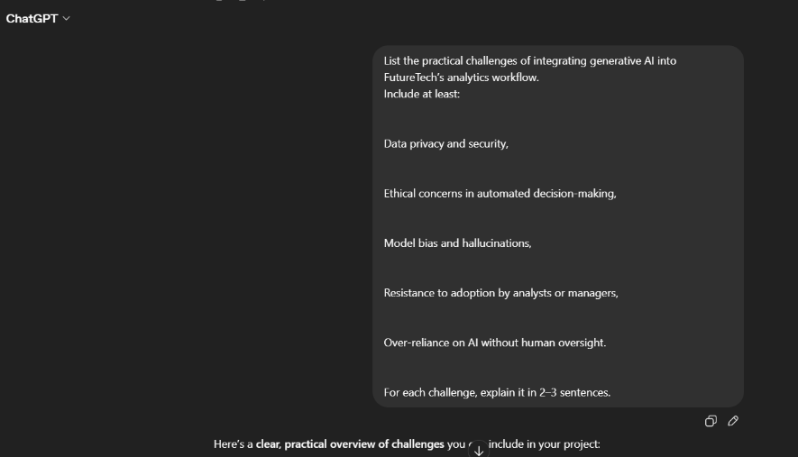
  - Challenges list
Screenshot 9: Identified challenges in integrating GenAI into analytics workflows at FutureTech.
Response:
⚠️ Challenges of Integrating Generative AI in FutureTech’s Analytics Workflow
1. 🔐 Data Privacy and Security
IoT data often contains sensitive information such as user behavior patterns and device usage. Integrating GenAI systems increases the risk of data exposure, especially if models are connected to external APIs or cloud services. Ensuring compliance with data protection regulations and implementing strong encryption and access controls is critical.

2. ⚖️ Ethical Concerns in Automated Decision-Making
GenAI systems may generate recommendations that influence business decisions without full transparency. This can raise ethical concerns, especially if decisions impact customers (e.g., service prioritization or pricing). Organizations must ensure fairness, accountability, and clear governance over how AI-driven decisions are used.

3. 🤖 Model Bias and Hallucinations
Generative AI models can produce biased or factually incorrect outputs (hallucinations), especially if trained on incomplete or skewed data. In an IoT context, this could lead to misleading insights about device performance or customer behavior. Continuous validation and human review are necessary to maintain accuracy.

4. 👥 Resistance to Adoption (Change Management)
Analysts and managers may be hesitant to trust or adopt GenAI tools due to lack of familiarity or fear of job displacement. This resistance can slow down implementation and reduce the effectiveness of AI initiatives. Proper training, clear communication, and demonstrating value are key to driving adoption.

5. ⚠️ Over-Reliance on AI Without Human Oversight
There is a risk that teams may rely too heavily on AI-generated insights without critically evaluating them. This can lead to poor decision-making if the AI output is incorrect or misinterpreted. A “human-in-the-loop” approach is essential to ensure that AI supports, rather than replaces, expert judgment.
Here ChatGPT identifies practical challenges of using GenAI in analytics, including data privacy, ethical concerns, model bias, and resistance to adoption. Recognizing these risks is crucial before large-scale deployment.
  - Strategies/solutions
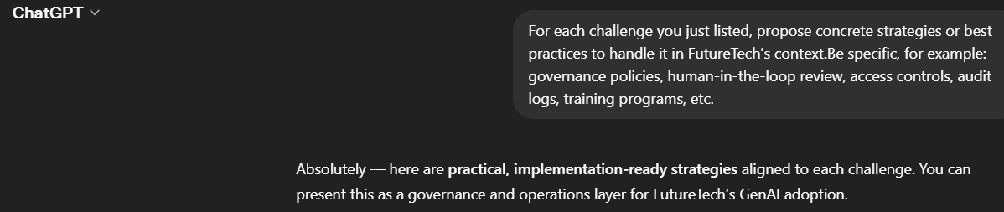
Screenshot 10: Recommended strategies proposed by ChatGPT to mitigate GenAI integration challenges.
Response:
Absolutely — here are practical, implementation-ready strategies aligned to each challenge. You can present this as a governance and operations layer for FutureTech’s GenAI adoption.

🛠️ Mitigation Strategies for GenAI Integration Challenges
1. 🔐 Data Privacy and Security
Strategies & Best Practices:
- Role-Based Access Control (RBAC): Restrict access to sensitive IoT data (e.g., customer-level usage) based on job roles.
- Data Encryption: Apply encryption at rest and in transit for all datasets and API communications.
- Data Anonymization/Masking: Remove or mask personally identifiable information (PII) before feeding data into GenAI models.
- Private/Enterprise AI Deployment: Prefer secure, enterprise-grade environments (e.g., private cloud or VPC) over public APIs for sensitive workloads.
- Audit Logs & Monitoring: Maintain logs of who accessed data, when, and for what purpose to ensure traceability and compliance.

2. ⚖️ Ethical Concerns in Automated Decision-Making
Strategies & Best Practices:
- AI Governance Framework: Establish clear policies defining where and how AI-generated insights can be used in decision-making.
- Explainability Requirements: Ensure AI outputs include reasoning or supporting data (e.g., “why this recommendation was made”).
- Human Approval Layer: Require managerial approval for high-impact decisions (e.g., customer actions, pricing changes).
- Ethics Review Board: Create a cross-functional team to review sensitive use cases and ensure fairness and accountability.
- Bias Audits: Periodically evaluate outputs for unfair or discriminatory patterns.

3. 🤖 Model Bias and Hallucinations
Strategies & Best Practices:
- Human-in-the-Loop Validation: Analysts review and verify AI-generated insights before they are shared or acted upon.
- Grounding with Trusted Data: Ensure GenAI outputs are based only on verified internal datasets (e.g., via retrieval-augmented generation).
- Prompt Engineering Standards: Use structured prompts to reduce ambiguity and improve output reliability.
- Benchmark Testing: Regularly test model outputs against known scenarios to check accuracy.
- Feedback Loop: Allow users to flag incorrect outputs and continuously improve the system.

4. 👥 Resistance to Adoption (Change Management)
Strategies & Best Practices:
- Training & Upskilling Programs: Conduct workshops to help analysts and managers understand how to use GenAI tools effectively.
- Pilot Projects: Start with small, high-impact use cases (e.g., automated reporting) to demonstrate value.
- Clear Communication: Position GenAI as a support tool, not a replacement for human roles.
- Champion Users: Identify early adopters within teams to advocate for GenAI usage.
- User-Friendly Interfaces: Integrate GenAI into familiar tools (e.g., dashboards) to reduce friction.

5. ⚠️ Over-Reliance on AI Without Human Oversight
Strategies & Best Practices:
- Human-in-the-Loop Workflow: Require human validation for all critical insights and recommendations.
- Confidence Scores & Flags: Display uncertainty levels with AI outputs to guide decision-making.
- Standard Operating Procedures (SOPs): Define when AI outputs can be trusted and when escalation is required.
- Dual Validation: Combine AI insights with traditional analytics or rule-based checks.
- Accountability Framework: Assign responsibility to specific roles (e.g., analyst, manager) for final decisions.
Here it shows proposed strategies to address these challenges, such as governance policies, human-in-the-loop review, and training programs. These recommendations form the basis for a responsible GenAI adoption plan.

- Integration framework
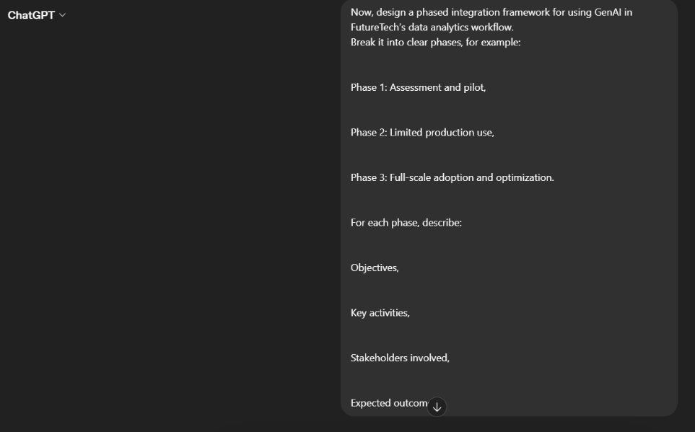
  - Phased integration framework
Screenshot 11: Phased GenAI integration framework for FutureTech’s analytics process
Response:
Here’s a clear, structured phased framework you can directly include in your project. It shows how FutureTech can move from experimentation to full GenAI-driven analytics.

🏗️ Phased GenAI Integration Framework for FutureTech

🚀 Phase 1: Assessment & Pilot
🎯 Objectives
- Evaluate feasibility of GenAI in analytics
- Identify high-impact use cases (e.g., automated EDA, anomaly insights)
- Build internal confidence and initial capability

🔧 Key Activities
- Audit existing data infrastructure and quality
- Select 1–2 pilot use cases (e.g., automated reporting, anomaly explanation)
- Develop simple GenAI prototypes (e.g., AI-generated summaries from dashboards)
- Implement basic governance (data access controls, human review)
- Define success metrics (accuracy, time saved, user satisfaction)

👥 Stakeholders Involved
- Data Analysts
- Data Engineers
- IT/Security Team
- Business Managers (pilot users)
- GenAI/AI Specialists

✅ Expected Outcomes
- Proof of value for GenAI in analytics
- Identified risks and limitations
- Initial best practices and workflows
- Increased stakeholder buy-in

⚙️ Phase 2: Limited Production Use
🎯 Objectives
- Scale successful pilots into controlled production environments
- Integrate GenAI into existing analytics workflows
- Establish governance and reliability

🔧 Key Activities
- Integrate GenAI with BI tools (e.g., dashboards with AI-generated insights)
- Implement human-in-the-loop validation workflows
- Strengthen data pipelines (clean, structured, secure inputs)
- Introduce monitoring systems (accuracy checks, audit logs)
- Conduct training programs for analysts and managers

👥 Stakeholders Involved
- Analytics Teams
- BI Developers
- IT & Data Governance Teams
- Department Heads
- Compliance/Ethics Team

✅ Expected Outcomes
- Regular use of GenAI in reporting and insights generation
- Improved efficiency (faster analysis, automated summaries)
- Reduced manual workload for analysts
- Controlled and secure AI usage

🌐 Phase 3: Full-Scale Adoption & Optimization
🎯 Objectives
- Fully embed GenAI into decision-making processes
- Optimize performance, scalability, and business impact
- Drive data-driven culture across the organization

🔧 Key Activities
- Deploy enterprise-wide GenAI-powered analytics platforms
- Automate insight generation and anomaly detection at scale
- Implement advanced capabilities (predictive analytics, real-time insights)
- Continuously refine models using feedback loops
- Establish a formal AI governance framework (ethics, compliance, audits)

👥 Stakeholders Involved
- Executive Leadership (CXOs)
- All Business Units
- Data & AI Teams
- IT Infrastructure Teams
- Risk & Compliance Teams

✅ Expected Outcomes
- AI-driven decision-making across departments
- Proactive operations (predictive maintenance, early anomaly detection)
- Higher customer satisfaction and operational efficiency
- Sustainable competitive advantage through AI adoption

🧠 Final Strategic Insight
FutureTech should adopt a phased, controlled approach to GenAI integration—starting with small pilots, scaling responsibly, and eventually embedding AI into core business decision-making. This minimizes risk while maximizing long-term value.
Here it outlines a phased integration framework (assessment, pilot, and full-scale adoption) for implementing GenAI in FutureTech’s analytics workflow. Each phase has clear objectives, activities, and stakeholders.
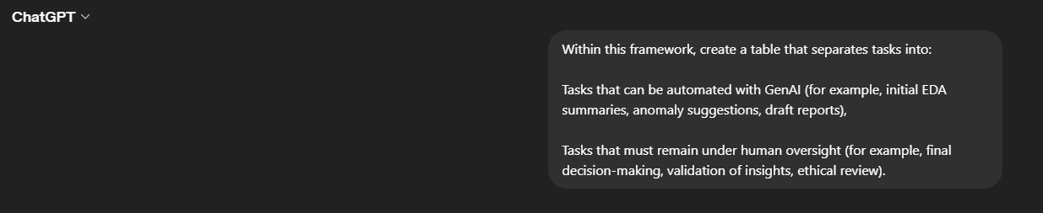
  - Tasks: automation vs human oversight
Screenshot 12: Division of tasks between GenAI automation and human oversight in the analytics workflow.
Response:
⚖️ Task Allocation in GenAI-Enabled Analytics Workflow
Tasks Automated with GenAI | Tasks Requiring Human Oversight
Automated EDA Summaries: Generate quick insights, distributions, and patterns from raw data | Validation of Insights: Verify accuracy and relevance of AI-generated findings
Trend Detection: Identify patterns over time (usage, alerts, performance) | Business Interpretation: Align insights with business context and strategy
Anomaly Detection Suggestions: Flag unusual patterns or outliers in device behavior | Root Cause Analysis: Investigate why anomalies occurred
Natural Language Report Drafting: Create initial reports, summaries, and dashboards narratives | Final Report Approval: Ensure clarity, correctness, and appropriateness for stakeholders
Data Querying via Natural Language: Allow users to ask questions and get instant insights | Critical Decision-Making: Approve actions like product changes, pricing, or customer interventions
Visualization Recommendations: Suggest best charts based on data patterns | Visualization Validation: Ensure charts are meaningful and not misleading
Customer Segmentation Suggestions: Automatically group users/devices based on behavior | Strategic Segmentation Decisions: Decide how segments are used in business strategies
Predictive Insights (Early Warnings): Suggest potential failures or risks | Action Planning: Decide operational or strategic responses
Data Cleaning Suggestions: Recommend handling of missing values or inconsistencies | Data Governance Approval: Ensure compliance with policies and standards
Insight Narratives (Storytelling): Convert analysis into simple explanations | Ethical Review & Compliance Checks: Ensure fairness, transparency, and no harmful bias

🧠 Key Takeaway
Generative AI should act as an intelligent assistant, not a decision-maker. While it can significantly accelerate analysis and insight generation, human expertise remains essential for validation, context, ethics, and final decision-making.
As shown above, tasks are separated into those suitable for GenAI automation (for example, initial EDA summaries, draft reports) and those requiring human oversight (for example, validation, final decisions, ethical review). This balance helps maintain both efficiency and accountability. FutureTech should adopt a hybrid model where GenAI automates repetitive and analytical tasks, while human experts retain control over validation, interpretation, and decision-making to ensure accuracy, accountability, and ethical compliance.
Generative AI does not replace analytics—it amplifies it. By combining AI-driven insights with human expertise, FutureTech can unlock smarter, faster, and more strategic decision-making.
In this project, I showed how ChatGPT can support the entire analytics workflow for IoT smart device data at FutureTech Solutions—speeding up EDA, helping design visualizations, and creating clear management-level insights. At the same time, I identified key risks such as privacy, ethics, and bias, and proposed a phased integration framework where GenAI acts as a co-pilot while humans retain final control over decisions.

